**ASSIGNMENT – 17.1**

**Problem Statement:**

Write a program that accepts the job_id as argument and returns a custom counter and a system counter (total records input to the map tasks) associated with that job.

**Program:**

**Driver Class:**

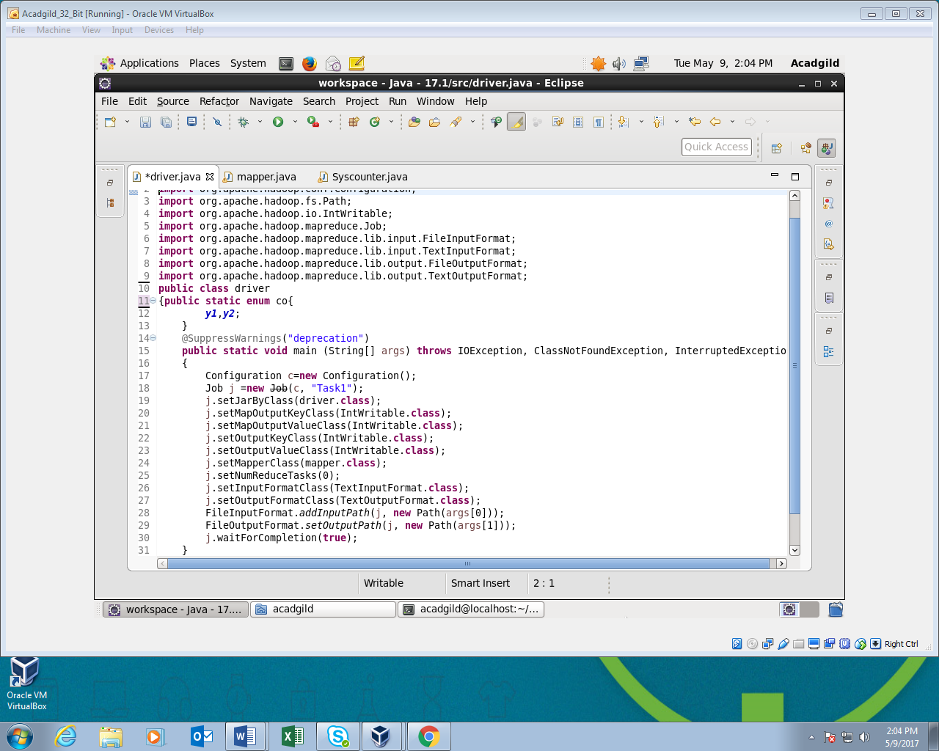

**Mapper Class:**

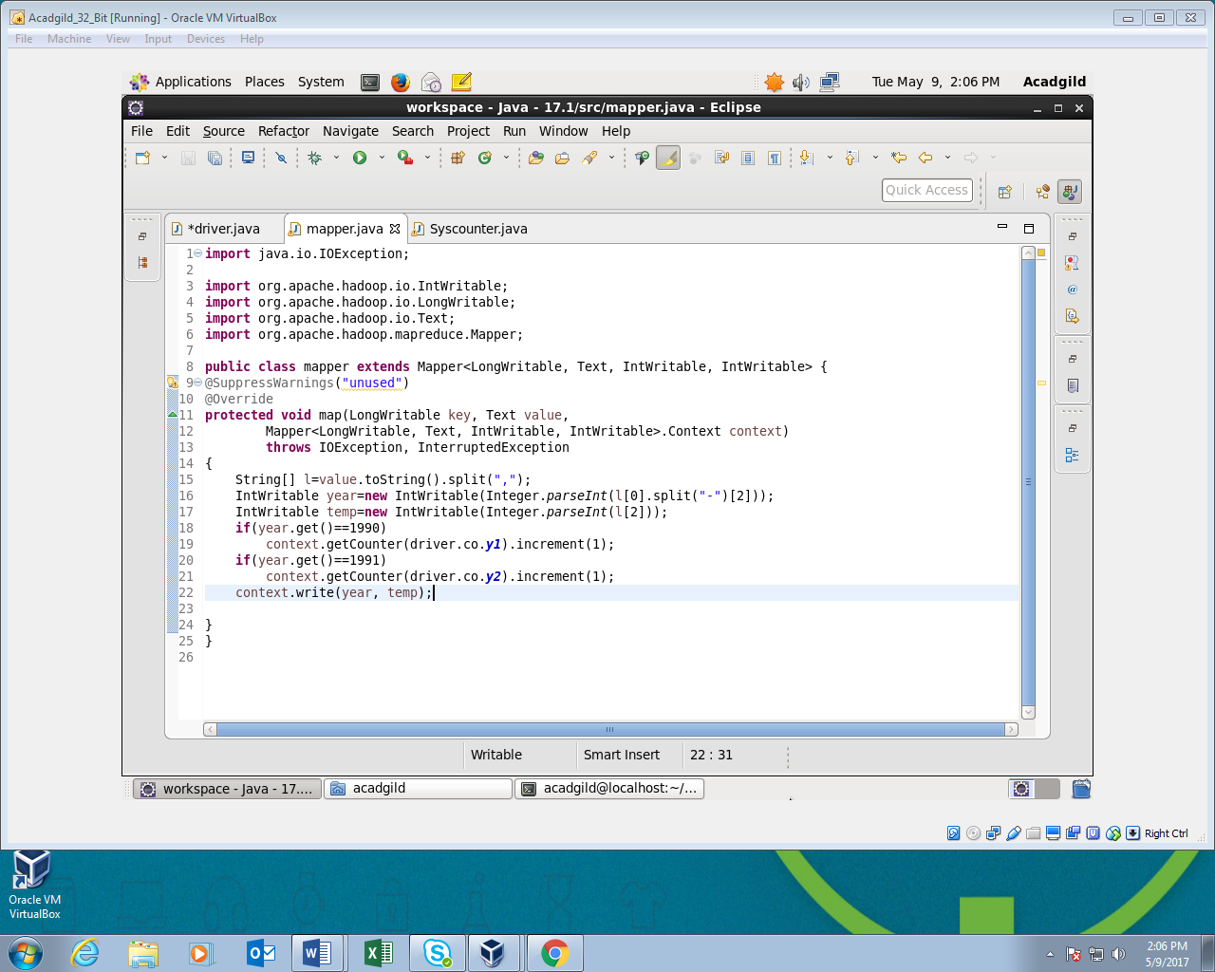

**Syscounter Class:**

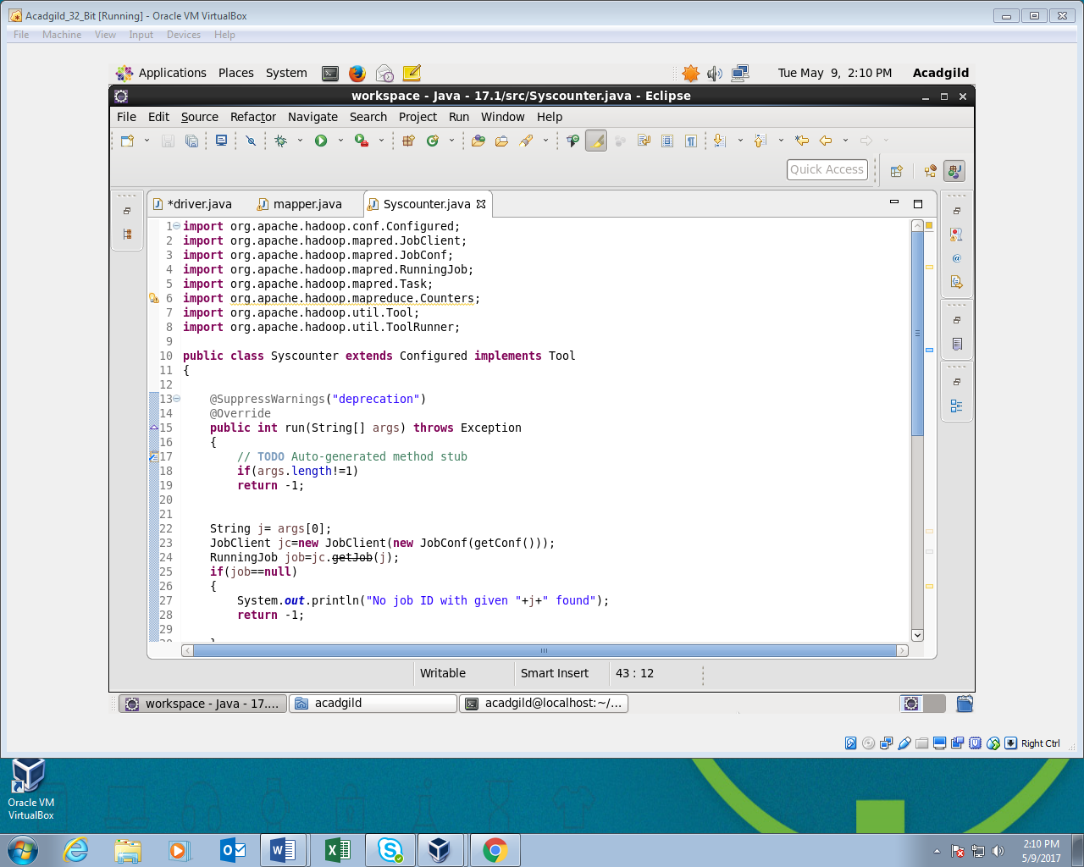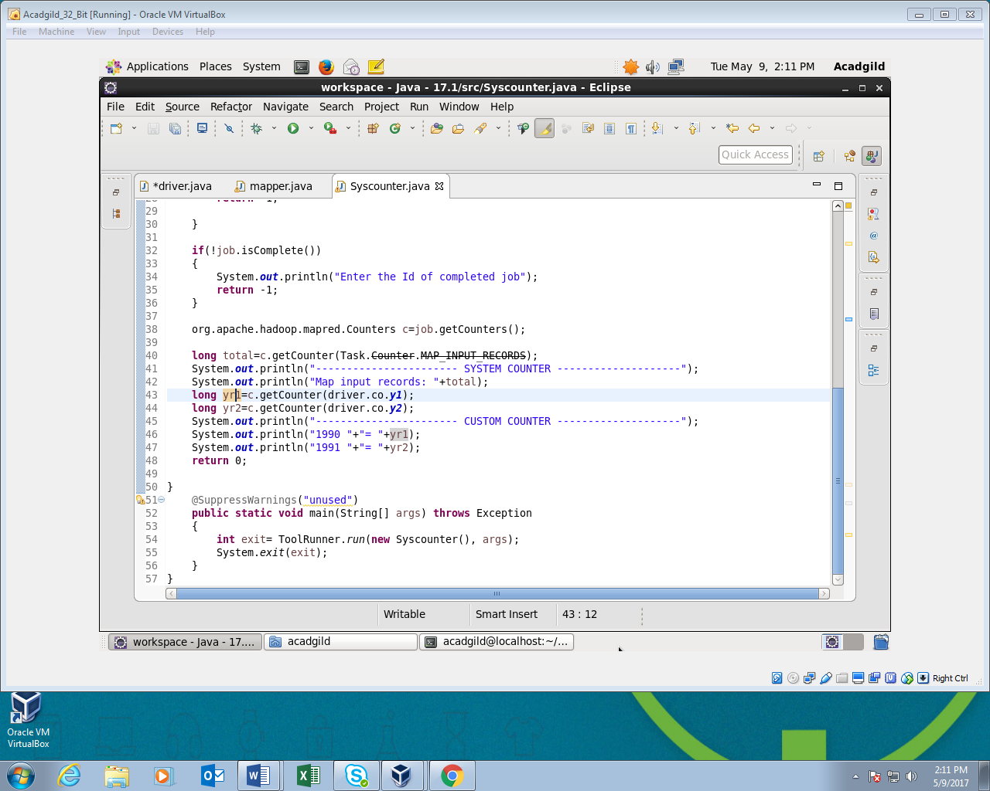

**Output:**

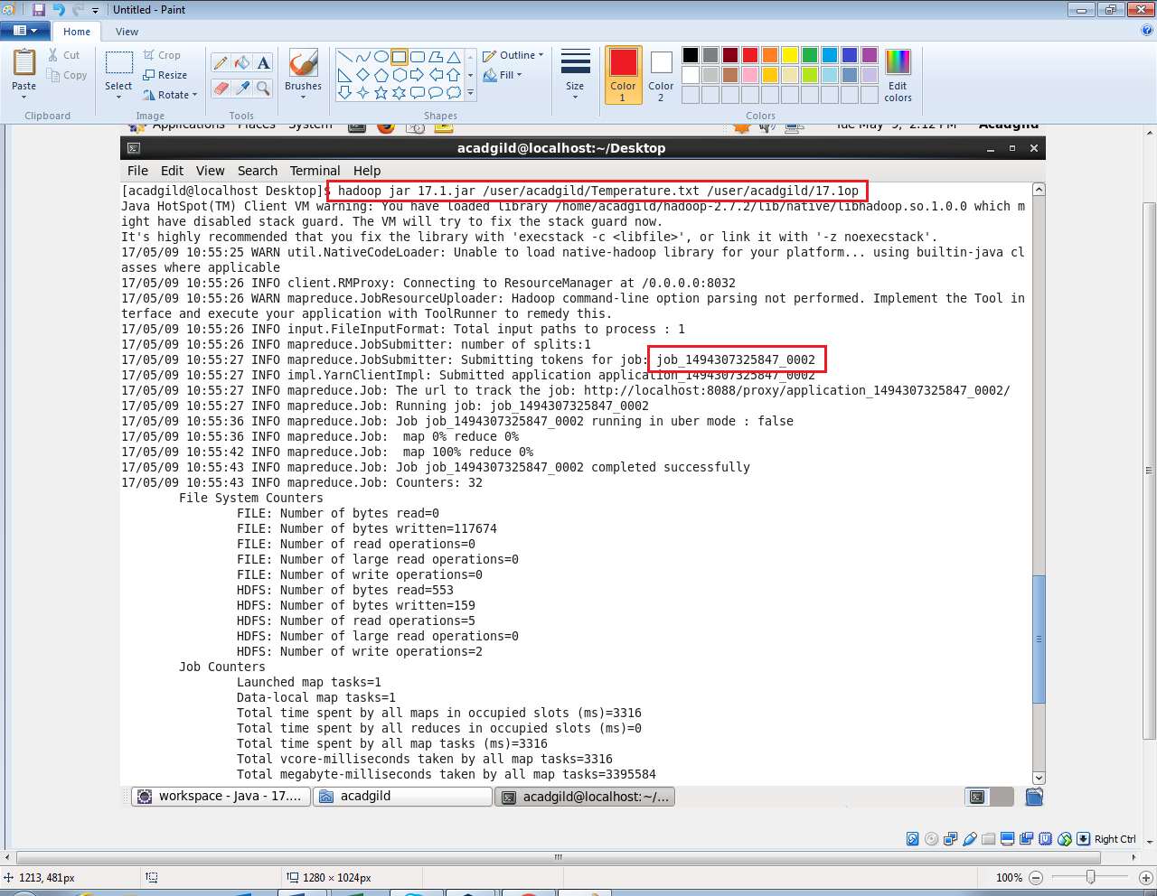

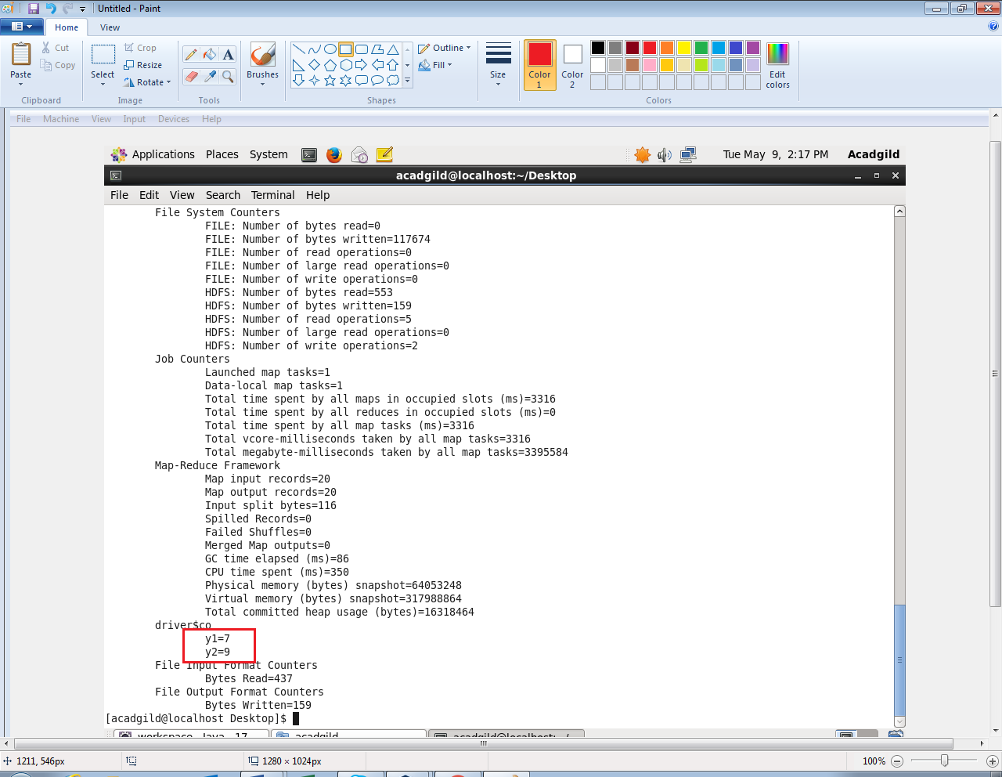

**We can see the custom counter in job history as below:**

